MDQServer Design

Overview

Current processing
Currently, Pds queries TPF whenever it needs to get Market Data. In QPE Phase 2 market quotes will not be sent to Tpf by CBOEDirect. Therefore Pds will have to query CBOEDirect for MD instead of TPF.

New requirement
A new process will be added to CBOEDirect to receive queries from Pds, route them to appropriate MDBroadcastAdapter and return the query result. Pds-es will use NAPI over TCP protocol to send/receive the queries to/from CBOEDirect.
There could be multiple instances of this process running for load sharing and/or backup purposes.

New process
The new process will be called MDQServer and will reside on the mdgc2 cluster. The connectionServer framework will be used to manage the TCP connections. MDQServer will open a server socket and will listen for client connections coming from PDS-es.
After parsing each of the queries MDQServer will make a synchrounous CORBA method call into one of the MDBroadcastAdapters. The routing of the request will be performed based on the class symbol. The MDBroadcastAdapter will return the result which will in turn be formatted into a response message and sent to back to the PDS.

Message Flow
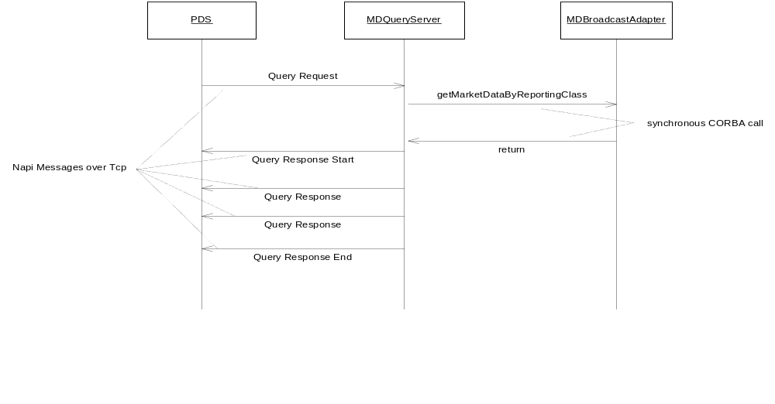
PDS will send a single request message per reporting class to MDQueryServer. MDQueryServer will parse the message, look up the reporting class in the DerivedCache and make a synchronous CORBA call into one of the MDBroadcastAdapters to retrieve the data. Upon receiving the retun result it will first send a QueryResponseStart message followed by one or more QueryResponse messages. As the last message the QueryResponseEnd is sent to signal that the download has been completed and there is no more responses coming for the given request.

MDQueryServer internal processing
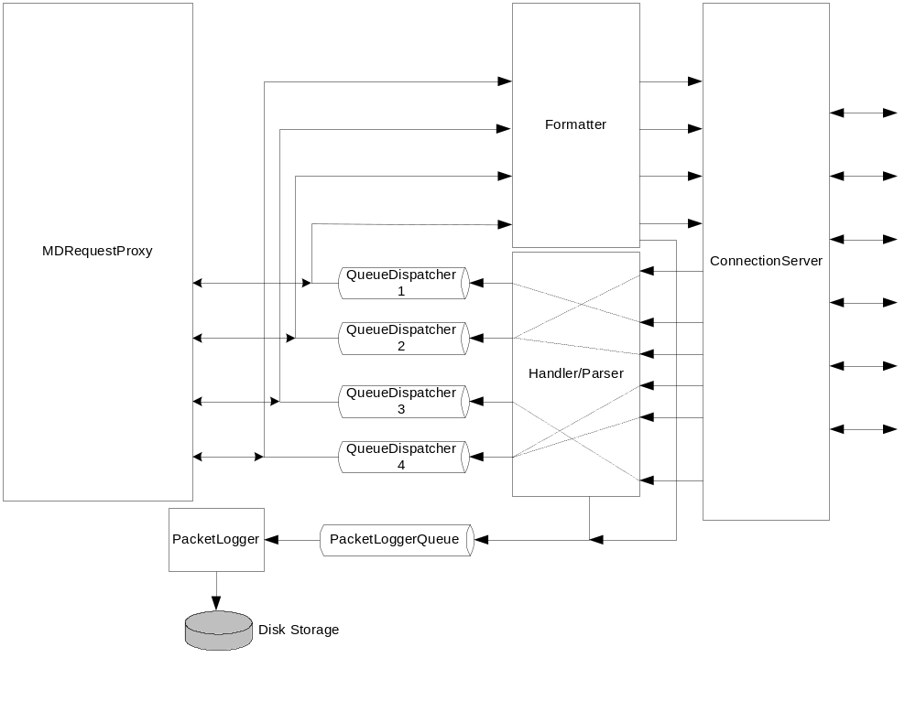
Each PDS will establish a connection with MDQueryServer. For each request coming from PDS the handler will determine the reporting class key by doing a lookup in the DerivedCache. If the reporting class cannot be found in CBOEDirect, an error message will be generated and sent back with an error code.
Each request will be passed by the handler to one of the QueueDispatchers. There will be one QueueDispatcher set up per MDBroadcastAdapter instance. All classes configured on a given MDBroadcastAdapter will be passed to the same QueueDispatcher. The assignment of a QueueDispatcher to MDBroadcastAdapter instance will be done through xml. The dequeueing thread will make the CORBA call through the MDRequestProxy and then create a response message based on the data received from MDBroadcastAdapter.
Each QueueDispatcher will have one or more queues configured (changeable through xml). Within each dispatcher requests will be routed to a particular queue based on the reporting class key. This way we can control how many parallel queries can be run into the same MDBroadcastAdapter.
Initially we will configure 8 dispatchers and 3 queues per each dispatcher.

PacketLogging
All incoming and outgoing NAPI messages will be logged to a single file using PacketLogger. Tools will be provided to display the contents of the log file in readable format.

Query Request message format
 | PDS Field | Length | Binary/ASCII | Values | Notes
 | Napi Header | 2 | B
 | MsgType | 4 | B | 100 | Request
 | RequestId | 4 | B
 | No of fields | 4 | B
 | FieldType | 2 | B | 1=ClassSym
 | Field Len | 2 | B
 | Field Data

Query Response Start message format
 | PDS Field | Length | Binary/ASCII | Values | Notes
 | Napi Header | 2 | B
 | MsgType | 4 | B | 101 | Response Start
 | RequestId | 4 | B
 | No of fields | 4 | B | 0

Query Response message format
 | PDS Field | Length | Binary/ASCII | Values | Notes
 | Napi Header | 2 | B
 | MsgType | 4 | B | 102 | Response
 | RequestId | 4 | B
 | No of fields | 4 | B
 | FieldType | 2 | B | 0x2 = ProductId 0x3 - Market Indicator 0x8 - Last Sale 0x9 - Book Bid Price 0x10 - Book Ask Price 0x11 - Book Bid Size 0x12 - Book Ask Size 0x13 - NonCust Bid Size 0x14 - NonCust Ask Size 0x15 - EOP Price 0xC - Market Bid Price 0xD - Market Ask Price 0xE - Market Bid Size 0xF - Market Ask Size
 | Field Len | 2 | B | 0x2 - 12 bytes 0x3 - 1 bytes 0x8 - 8 bytes 0x9 - 8 bytes 0x10 - 8 bytes 0x11 - 2 bytes 0x12 - 2 bytes 0x13 - 2 bytes 0x14 - 2 bytes 0x15 - 9 bytes 0xC - 9 bytes 0xD - 9 bytes 0xE - 2 bytes 0xF - 2 bytes
 | Field Data

Query Response End message format
 | PDS Field | Length | Binary/ASCII | Values | Notes
 | Napi Header | 2 | B
 | MsgType | 4 | B | 103 | Response End
 | RequestId | 4 | B
 | No of fields | 4 | B | 0

Query Response Error message format
 | PDS Field | Length | Binary/ASCII | Values | Notes
 | Napi Header | 2 | B
 | MsgType | 4 | B | 104 | Error Response
 | RequestId | 4 | B
 | No of fields | 4 | B | 1
 | FieldType | 2 | B | 0xFFFF - error code
 | Field Len | 2 | B | 1
 | Field Data |  |  | 1 - System Error 2 - Class Not Found

Scripts(2)
- connectionStatus
- startServer
- globalExternalServices
- mdqAdmin – new script
- template scripts for new xmls
- startTradeengSystem
- stopTradeengSystem
- appDTD.txt
- appXML.txt
- appXMLTemplates.txt

Database(.5)
- None

SetContext(.125)
- setContext.main
- setContext

XML/DTD(.5)
- MDQServer.xml/dtd - new file
- MDBQueryConnectionService.xml/dtd – new file
- MDBQueryMessageHandler.xml/dtd – new file
- SBTLoggingService.xml
- MDQPacketLoggerHome.xml – new file
- MDQServer.xml.template – new file
- XML re-genration required

Homes/Services(4)
ConnectionServiceHome
QueueHome,
ProductQueryServiceHome,
ProductConfigurationServiceHome,
ProductConfigurationStatusConsumerHome,
ProductStatusConsumerHome,
TradingSessionConsumerHome
PacketLoggerHome
DerivedCache
MDBQueryServiceImpl – new connectionServer.Service implementation
MDBQueryMessageHandlerImpl – new impl
MDRequestServiceProxy – new proxy

ImplPlan(.5)
- These changes should be implemented on both sides of the cluster before the first class is enabled for QPEP2.

PerformanceTestingProcedure(1)
- Configure a test driver with 20 connections. Determine the maximum query rate when:
    - All connections use an identical set of classes and the queries are started at the same time.
    - Each connection has a unique set of classes. These classes are distributed randomly between all MDBRoadcastAdapter instances.
Monitor the GC activity and CPU usage.

TestingProcedure(1)
- New test driver will be written to perform the following
Step 1: Establish TCP connection to MDQServer.
Step 2: Publish current market for all series in a reporting class.
Step 3: Send a query for that class, retrieve the data and compare with what was published.

Run the test above in 20 threads for 20 different classes. Repeat Step 2 and Step 3.
- Failover test:
Step 1: Establish TCP connection to MDQServer on the A side of the cluster.
Step 2: Publish current market for all series in a reporting class.
Step 3: Send a query for that class, retrieve the data and compare with what was published.
Step 4: Kill all the A side processes
Step 5: Have the driver reconnect with the B side MDQServer
Step 6: Send a query for that class, retrieve the data and compare with what was last published.

OperatorProcedure(.5)
- The new process will need to be started and shut down by OPS ( Control M setup ).
- The new process will be added to Patrol.
- Failover procedure for mdgc2 will be updated to reflect the new process. ConnectionStatus and globalExternalServices scripts will be updated to handle the new connections

Fallback/Failover
All processes have to be failed over.

Open issues:
1.
What should be sent to Pds in response to a query in case if the MDBroadcastAdapter cache has not been initialized for a particular field ? Should the field be initialized to some default value or maybe it should not be included in the message at all.

2.
The message formats have to be finalized and confirmed with Pds.

